VPN (Virtual Private Network)
# Source: Chatgpt (GPT‑5 Mini) at [1/14/2026]
A VPN (Virtual Private Network) is a technology that creates a secure, encrypted connection between your device and the internet by routing your traffic through a private server.

🔐 Definition:
# Source: Chatgpt (GPT‑5 Mini) at [1/14/2026]
A VPN hides your real IP address and encrypts your internet traffic, making your online activity private, secure, and untraceable — even on public networks.

🌐 How VPN Works:
# Source: Chatgpt (GPT‑5 Mini) at [1/14/2026]

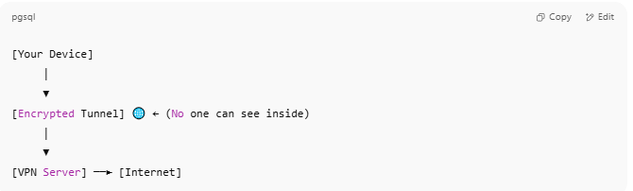

[Your Device]
│
▼
[Encrypted Tunnel] 🌐 ← (No one can see inside)
│
▼
[VPN Server] ──► [Internet]

- You connect to a VPN app.
- The VPN app encrypts your data and sends it to a VPN server.
- The VPN server decrypts it and forwards the request to the internet.
- The response returns the same way — encrypted and hidden.

How VPN works photo
# Source: Multi sources: How VPN works -> at - (Top)
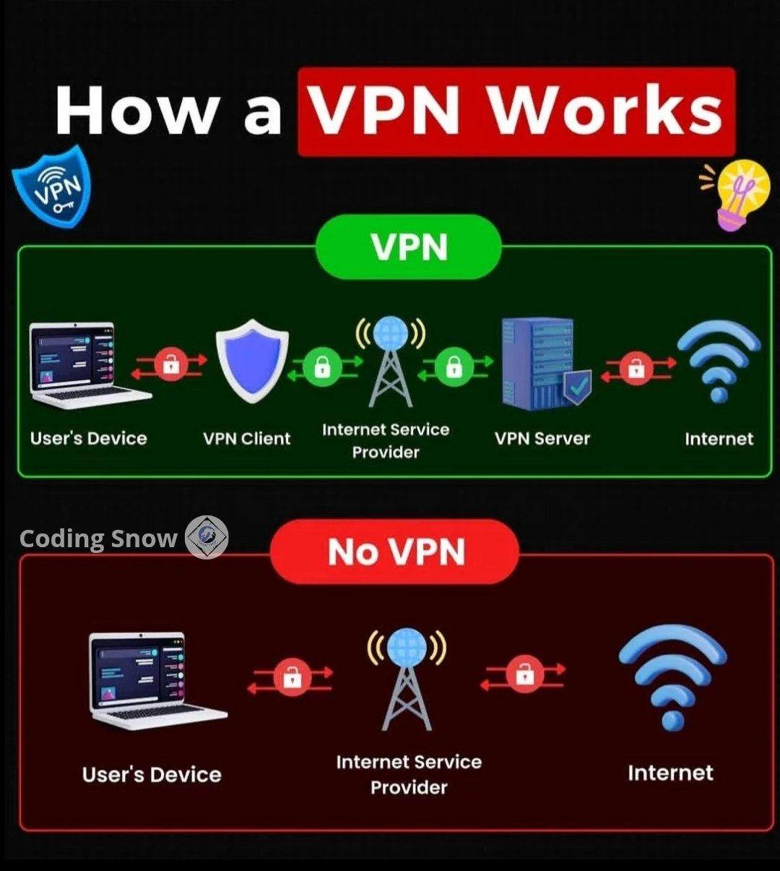

🎯 What VPN Does:
# Source: Chatgpt (GPT‑5 Mini) at [1/14/2026]
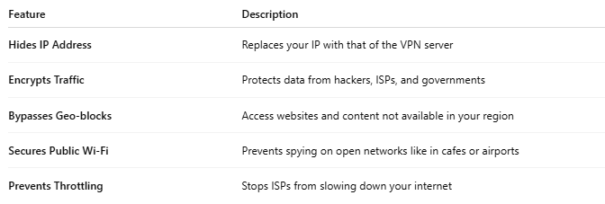

Feature | Description
Hides IP Address | Replaces your IP with that of the VPN server
Encrypts Traffic | Protects data from hackers, ISPs, and governments
Bypasses Geo-blocks | Access websites and content not available in your region
Secures Public Wi-Fi | Prevents spying on open networks like in cafes or airports
Prevents Throttling | Stops ISPs from slowing down your internet

✅ VPN vs Proxy:
# Source: Chatgpt (GPT‑5 Mini) at [1/14/2026]
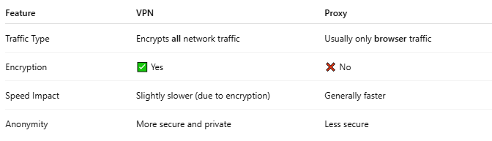

Feature | VPN | Proxy
Traffic Type | Encrypts all network traffic | Usually only browser traffic
Encryption | ✅ Yes | ❌ No
Speed Impact | Slightly slower (due to encryption) | Generally faster
Anonymity | More secure and private | Less secure

🧰 Common VPN Protocols:
# Source: Chatgpt (GPT‑5 Mini) at [1/14/2026]
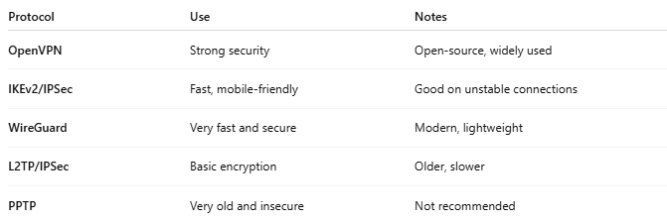

Protocol | Use | Notes
OpenVPN | Strong security | Open-source, widely used
IKEv2/IPSec | Fast, mobile-friendly | Good on unstable connections
WireGuard | Very fast and secure | Modern, lightweight
L2TP/IPSec | Basic encryption | Older, slower
PPTP | Very old and insecure | Not recommended

🛡️ Popular VPN Providers:
# Source: Chatgpt (GPT‑5 Mini) at [1/14/2026]
- NordVPN
- ExpressVPN
- Surfshark
- ProtonVPN
- CyberGhost

